0327 Fri

Whenever you have a gap down, and we did have a gap down, you need to give the market some time to find out if the market's gonna reverse as a bull trend back into the range of the gap, or is the day gonna have continuation down? Is it gonna be a bear trend day? Or is it more likely a trading range day? And if (we gapped down below LoY and) it's a trading range day, yesterday's low is always a magnet.

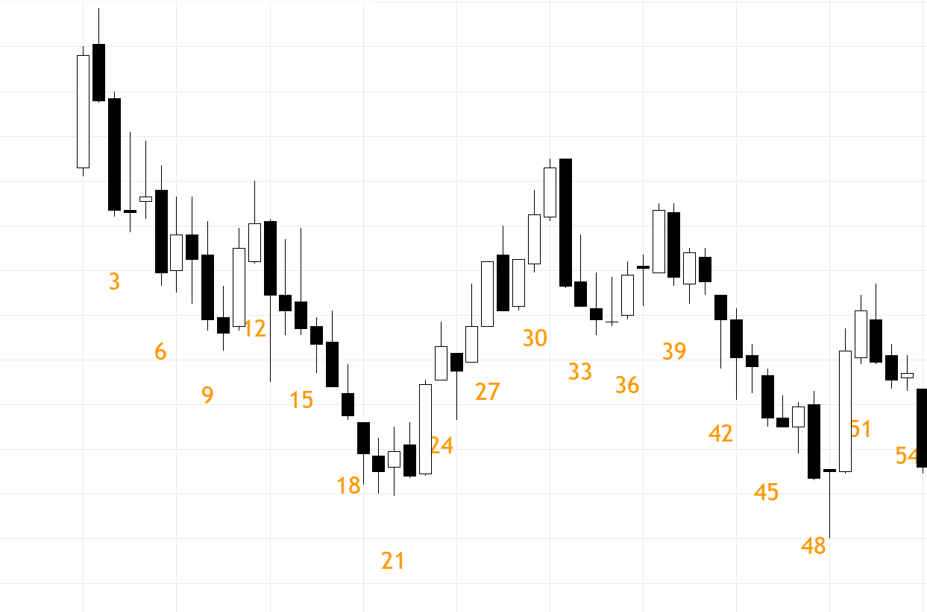
Short below B3, stop above 2 got 1R, long above B25 (with stop below LoD for another 1R). The Big Down (to B21) and Big Up (to B31) puts the market in TR. The selloff (to B21) never got strong and the day remained inside day all day. In TR sellers above prior highs buyers below prior lows.

Avoid trading the first six bars, look for either one side to be trapped or a pullback and 2nd leg in the initial direction. Doing anything on the first breakout of the day is a 50-50 bet. You cannot make money on the 50-50 bet, especially with all the commissions you pay, which will add up.
Remember, give it six bars to develop into what type of day it is. There is 50% chance that any move at the open is in the wrong direction and even if its not the ‘wrong’ move, there is still 70% chance that you're gonna get a second entry to enter in direction of the trend.
In bear trend, every big spike gets sold and the bears are making money selling every bull spike. And that's gonna continue for as long as the bear trend is in effect, regardless of news and what else is happening in the world. In the current times, the stagflation is actually the main problem, economy worsening and inflation rising. Even major breakthroughs in world peace, is not gonna change the impact of inflation. Giving people free money creates more inflation. Just like the covid-era, no vaccine changed the impact of inflation on the market.
Just like running a store in a famer’s market, you decide the price you want to buy or sell. Nobody needs to buy or sell at any price. Likewise in trading, decide where you want to enter and wait. If market is trending down but price you want to sell is higher, you have to wait until you get a pullback.
Don’t chase the market. Chasing often leads you into taking a bad short at the low or bad buy at the high. You plan the trade and then when it sets up, you trade the plan and you hold it into the target down here.

Missing the first move
Don't be discouraged if you miss the first move. That is actually good. You give yourself some time to let the market determine what type of day it is. Even if you miss the very first move, you're gonna get lots of time to get in on the action throughout the day.

